Power BI Version Control using GIT and Azure DevOps by taik18 - YouTube
taik18 - Mohammed Adnan

https://www.youtube.com/watch?v=fWamDXiOmvE

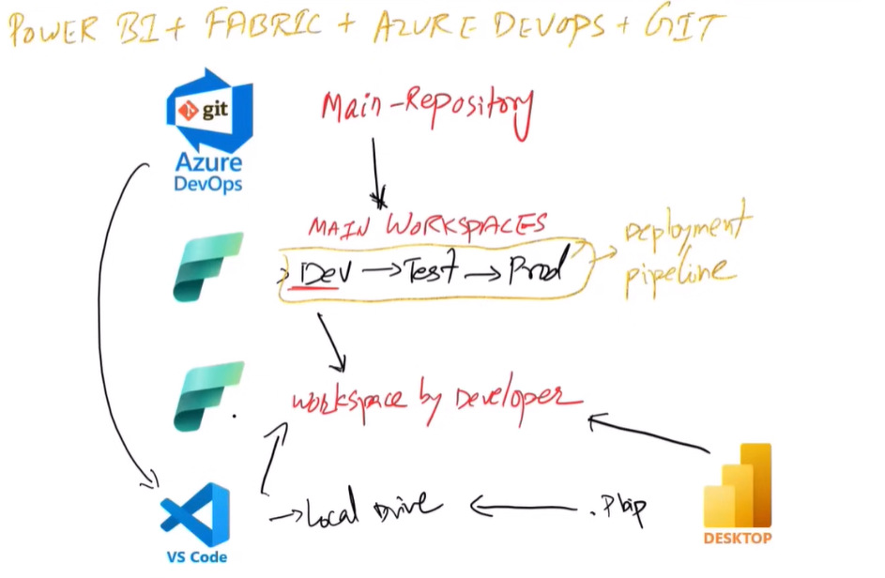

Steps:
- Connect Azure Devops to the repository on VS Code
- Sync it to the local drive
- Save the power BI Desktop file as a .PBIP File Sync to Devops sync to power bi service
- Create a Branch in Devops
- Open the branch Clone Repository Clone in VS Code
- Select the Local folder for repository destination
- In Power BI Service, workspace workspace settings Git Integration select the branch Switch and Override
- Now if you publish a report directly from power BI Desktop to Service, it will show as Uncommited.
- In Power BI Service, To commit that, click on the Source Control select the branch select the list of reports to commit
- Open Devopsgo the branch create a pull request approve main branch will be updated with this merge.
- Now come to power bi Service Go to destination workspace where it is mapped with main branch you will see the notification ”You have unsynced commits” Source Control update all
- Now come to VS Code Source Control Sync Changes Now the changes are updated in the local Folder and you will observe that there are two Folders, one for Dataset and the other for the Report unlike one single File when downloaded directly from Power BI Service.
- To Save the Power BI File as a .PBIP File, Power BI Desktop File Options and Settings Options Preview features enable Power BI Project(.pbip) option
- Note:
- publishing the report from power BI Desktop to Power BI Service will go along with updated and refreshed datasets
- Publishing the report from Fit/Devops to Power BI Service will take forward only the report metadata.

